**Dungeon Paper**

## Abstract

Dungeon Chain (DGN) introduces a pioneering blockchain solution tailored for the gaming industry, offering ultra-fast block times, minimal transaction fees, and leveraging partial set security from the Cosmos Hub validator set. This white paper details the technical intricacies, features, tokenomics, and strategic advantages of Dungeon Chain, positioning it as the catalyst for a future of decentralized gaming.

## Introduction

The gaming sector demands swift transactions and economical solutions, yet current blockchain frameworks often falter under these pressures, plagued by high costs and sluggish processing speeds. Dungeon Chain addresses these challenges head-on by harnessing cutting-edge blockchain technology to deliver rapid transaction times and nominal fees, redefining the landscape of decentralized gaming. By incorporating partial set security from the Cosmos Hub validator set, Dungeon Chain enhances its security and decentralization, ensuring robust protection for user assets and transactions.

## Technical Overview

**Consensus Mechanism:** Dungeon Chain employs a proof-of-stake (PoS) consensus model, ensuring energy efficiency and scalability while maintaining robust security protocols.

**Block Times:** Dungeon Chain boasts an ultra-fast block time, significantly reducing latency and optimizing user interactions. A smaller validator set is used to achieve this.

**Transaction Fees:** With ultra low transaction fees, Dungeon Chain eliminates financial barriers for developers and gamers alike, fostering widespread adoption.

**Partial Set Security:** Utilizing partial set security from the Cosmos Hub validator set enhances Dungeon Chain's security posture, leveraging the trusted validators of the Cosmos ecosystem. This provides us validators with the fastest block times.

**Scalability:** Leveraging innovative sharding techniques and off-chain solutions, Dungeon Chain scales seamlessly to accommodate heightened network demands, and ensuring consistent performance during peak periods.

## 

## Features of Dungeon Chain

1. **Smart Contract Capabilities:** Dungeon Chain supports Cosmwasm smart contracts, empowering developers to create sophisticated gaming applications effortlessly.
2. **Interoperability:** Dungeon Chain is designed to integrate seamlessly with other blockchains and gaming platforms, promoting an interconnected ecosystem for developers and users.
3. **Decentralized Governance:** Dungeon Chain implements a decentralized governance framework, enabling stakeholders to participate in protocol upgrades and decision-making processes.
4. **Security Measures:** Built upon advanced cryptographic principles, Dungeon Chain guarantees secure transactions and data integrity, safeguarding user assets and identities.

**Synergy and Added Value to Cosmos Stakers**

By becoming a member of the Cosmos shared security model we benefit from being able to utilize the already robust security of the Cosmos Validator set.

Our new blockchain and game will connect communities in the cosmos ecosystem together by encouraging them to use other blockchains by questing in our game. This will drive up transactions not only in our chain but in many other chains in the ecosystem as well as IBC transactions using atoms. Because the game will be available on mobile platforms it has a chance to onboard a massive amount of non crypto users to the ecosystem.

**Tokenomics**

Dungeon Chain (DGN) tokenomics are designed to support a sustainable and vibrant ecosystem. Inflation will be kept low, facilitated by the decreased cost demand from utilizing the Cosmos Hub validator set. This approach ensures that the supply of DGN tokens remains stable and aligned with the growing demand from users, developers, and stakeholders within the gaming community. DGN tokens will be used for transactions, staking, governance participation, and rewarding ecosystem contributors, fostering a thriving economy within the Dungeon Chain.

**Token Utility:**

**- In-Game Currency:**

- Purchase in-game assets (weapons, skins, characters)

- Participate in special events and tournaments

- Stake for rewards and access premium features

**- Governance Token:**

- Vote on game updates, new features, and protocol changes

- Propose and fund new game developments and community projects

**Token Distribution:**

- Total Supply: 1,000,000,000 DGN

-Inflation Rate - 10% annual designed to reward stakers and pay validators with guaranteed funds until transactions become more substantial. This can be changed by governance later in the future. The number was chosen as we prefer conservative tokenomics.

**- Initial Distribution:**

- Dungeon Chain Foundation: 20% (for development, partnerships, and operational costs)

- Team and Advisors: 15% (vesting over 3 years) Tokens will be locked for 1 year with no inflation rewards

- Ecosystem Fund: 20% (supporting game developers, marketing, and community initiatives)

- Public Sale: 10% (raising initial funding)

- Liquidity Provision: 10% (ensuring market liquidity)

- Airdrop: 15% (10% will be allocated to first airdrop with 5% future drop to loyal users)

- Player Rewards 10%

**- Incentives and Rewards:**

- Play-to-Earn (P2E):

- Earn DGN by completing missions, winning battles, achieving milestones

- Special quests and achievements grant bonus DGN and rare in-game items

**- Staking Rewards:**

- Stake DGN to earn passive income in DGN and governance tokens

- Receive exclusive NFTs and in-game benefits

**- Referral Program:**

- Earn DGN by inviting new users

- Additional bonuses for referred players achieving specific milestones

**- Economic Sustainability:**

- Burn Mechanism:

- Small percentage of DGN used in transactions is burned, reducing total supply and increasing scarcity

- Seasonal events where players burn DGN to earn unique rewards

**- Treasury and Reserve:**

- Portion of transaction fees and marketplace sales goes into a treasury fund

- Treasury supports long-term development, game updates, and ecosystem growth

**- Dynamic Adjustments:**

- Periodic review and adjustment of token rewards and burn rates based on community feedback and economic conditions

- Active governance participation ensures balanced and sustainable ecosystem

## Use Cases in Gaming

1. **In-Game Asset Exchange:** Gamers can securely trade virtual assets using Dungeon Chain, enhancing liquidity and ownership transparency within gaming environments.
2. **Gaming Tournaments:** Dungeon Chain facilitates transparent and tamper-proof gaming tournaments, ensuring real-time settlement of rewards and fostering competitive integrity.
3. **Developer Incentives:** Dungeon Chain incentivizes developers to innovate through a low-cost transaction ecosystem and a vibrant developer community, promoting the creation of diverse gaming experiences.

**Kosmic Quest**

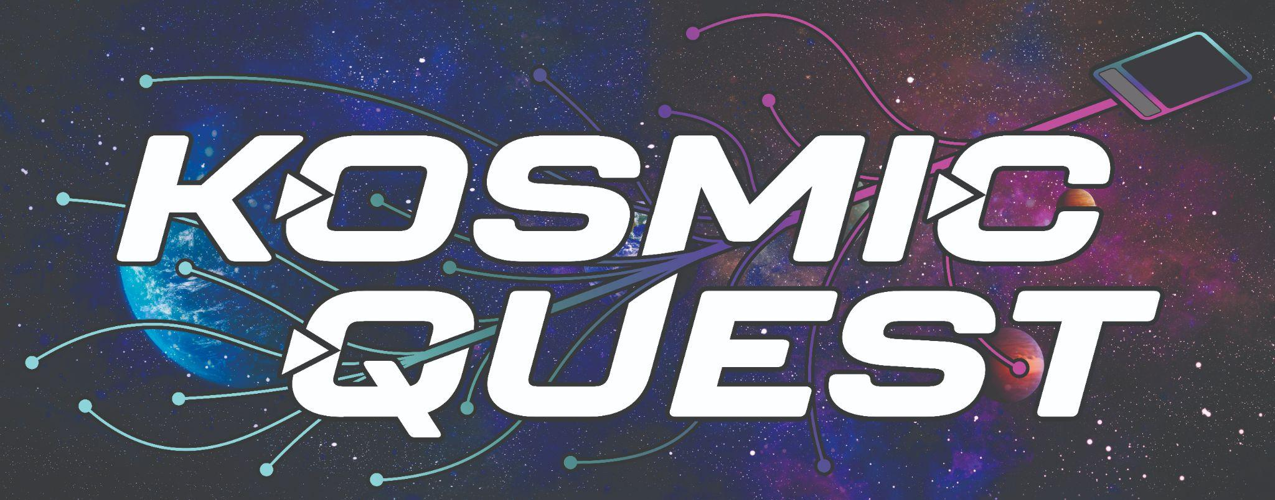

The game centers around trading and battling with NFT cards to stimulate intercommunication across various chains. Within the game, players will be encouraged to take their quest to different chains in order to acquire more cards and enhance their deck.

Continued growth upon the foundational interchain connectivity and community established by ***Kosmic Quest*** is planned to tie directly to our third gaming project. This project is planned to be an immersive 3D gaming experience within the metaverse. However, the regular development of updates and balancing for ***Kosmic Quest*** is anticipated to continue alongside the flourishing of the project’s community.

***Kosmic Quest*** is a free to play interchain deck-building game centered around collecting, trading, and battling with NFT-based cards. The initial launch of the game will see 400 different character NFTs minted on each chain. There will be play to earn features for those who choose to engage in web 3 (NFT holders/stakers),but this is not required.

This game is planned to be available on mobile devices and users will not need to know anything about crypto in order to play. On the front end this can be ran from our own servers and the back end is where the game will connect to individual blockchains.

Character races will be dependent upon the chain on which they are minted: Lions will emerge from Juno and Whales will arise from Migaloo. Characters across all chains will be based in 1 of 8 elemental subtypes (Light, Earth, Water, Fire, Darkness, Toxin, Ice, Hellfire) and have a background in 1 of 8 classes.

The game will be free to play on mobile app stores but crypto users will gain additional benefits for holding a special character NFT as well as possible additional benefits in game for staking crypto. An NFT is not required to play but non crypto users will soon notice the benefits of being an NFT holder/staker which will help to onboard non crypto users into the Cosmos Ecosystem. This could potentially attract large numbers of mobile gamers.

Upon entering the game, players will be greeted by a title screen showcasing an old-world styled map of a continent. Several locations are depicted on the map that correspond to specific dungeon nodes; each node is representative of a different Cosmos blockchain (Neutron, Juno, Archway, Migaloo, etc.) and is connected by a web of lines that lead back to a central hub. This is explained to players and helps them learn about the Cosmos Ecosystem.

Players will begin their quest on the node associated with their NFT’s chain and be set upon their journey with a small deck of cards. They are able to travel along the lines of the map to reach each node as they progress through the game. As the game expands to additional chains within the Cosmos ecosystem, so too will the map of the continent expand to include the newly formed nodes.

**Roadmap**

**Already Completed Milestones**

* Crypto Dungeon was launched in 2021 and started out as a grassroots community validator and we have substantially increased our community and supporters on Twitter and Discord. We are now in the active sets of 13 different cosmos SDK blockchains with plans to expand this is the future.
* We launched a successful NFT mint on stargaze which has a substantial floor and is one of the highest ranked projects and rising fast. This NFT mint has already provided our supporters with several airdrops and lifetime membership to our first game that has been launched which is being streamed on YouTube currently. We have two groups of professional actors that are being filmed for a television show that are playing in our game currently. Our 2nd NFT mint for “Kosmic Quest” is nearly complete and will launch next month on Stargaze as well as several other chains that have their own NFT platforms. Each of the NFT’s represent player characters in the game which give players different benefits for holding.

#### *Phase 1*

Launch of Dungeon Chain mainnet, initial platform integration with gaming applications, and community outreach initiatives. This will include the launch of Kosmic Quest this year which will launch its first node on Juno Blockchain and follow up with nodes on other blockchains that we validate for. Our first game which is a live action dungeons and dragons game is also being ported to our Blockchain

#### Phase 2

Expansion of developer tools and strategic partnerships with prominent gaming studios, fostering ecosystem growth and adoption. We plan to attract game developers by helping them launch on our permissioned chain.

Implementation of advanced scalability solutions and cross-chain interoperability features, solidifying Dungeon Chain's leadership in the gaming blockchain sector.

## Conclusion

Dungeon Chain represents a pivotal advancement in gaming blockchain technology, offering unparalleled speed, scalability, and cost-effectiveness. By empowering developers and gamers with a robust and user-centric platform, Dungeon Chain is poised to redefine the future of decentralized gaming.

Leveraging partial set security from the Cosmos Hub validator set and maintaining low inflation through reduced cost demand further enhances Dungeon Chain's sustainability and attractiveness. Join us on this transformative journey toward a more inclusive and innovative gaming ecosystem.

*Disclaimer:* This white paper serves solely as informational material and does not constitute financial or investment advice. Interested parties are encouraged to conduct independent research and due diligence before engaging with Dungeon Chain.

*Contact Information:* For more details about Dungeon Chain, visit our official website at [www.cryptodungeon.org](http://www.cryptodungeon.org) or contact us via email at [support@cryptodungeon.org](mailto:support@cryptodungeon.org)

You can also join our discord <https://discord.gg/FUugJ9D2Ga>

Our Team

The Crypto Dungeon team is made of an international group of professionals who have excelled in multiple worldly facets influencing business, academics, crypto enterprise, non-profit leadership, community development, gaming, and the arts.

❖ Dr. Lee Berman, MD/MBA (USA) - Founder and Chief Executive Officer

❖ Brad Rako, B.S. Computer Science (USA) - Founder and Chief Engineering Officer

❖ Dr. Sanju George, MD (USA) - Founder and Chief Financial Officer

❖ Donovan Chase (USA) - Dungeon Master and Lead Game Designer

❖ Joshua Short, MBA (USA) - Producer and Chief Operating Officer

❖ Dr. Cyril Guerette, PhD/MPhil (Canada) - Community Development Officer

❖ John Andrew Fuller B.A (USA) - IT Engineer and Software Developer

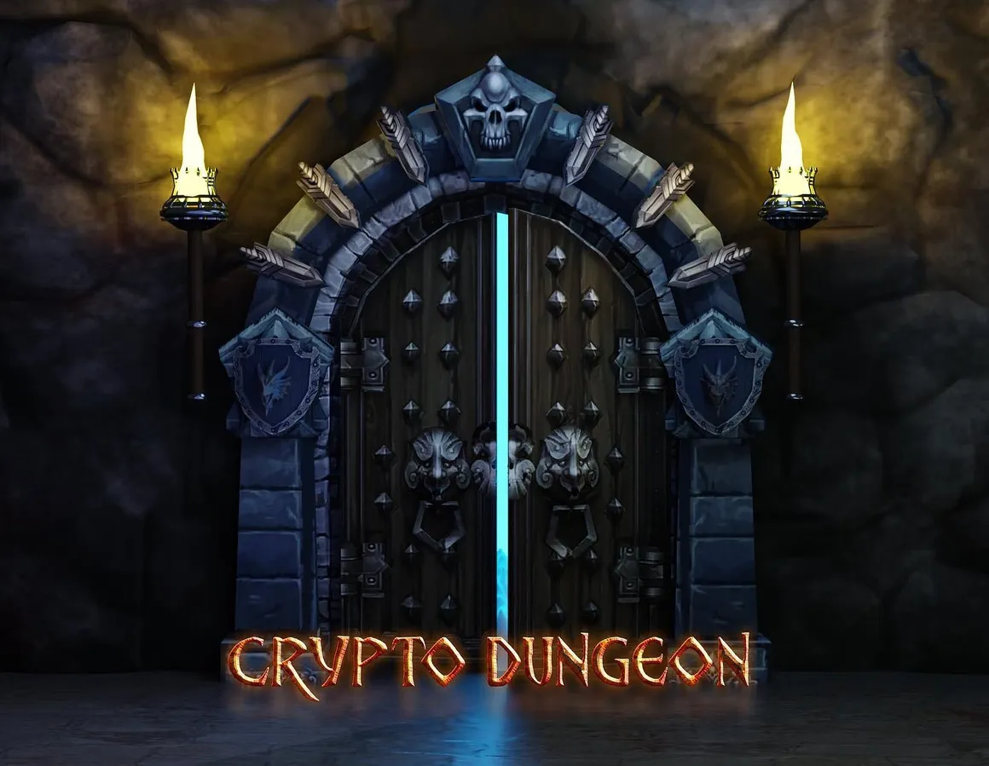

About Us

Crypto Dungeon[1](https://docs.google.com/document/d/1-MvaDHDOMZPG3sC1Bfvc-6tdHWb6IEfpa6W1voC-eB0/edit#bookmark=kix.wobpkzaoqre8) is a Cosmos Ecosystem Validator and Game Developer that aims to promote Cosmos and all of its projects through blockchain validation, interchain security, cross chain marketing, games, and streaming. We are located in Iowa, USA and our servers are located in an Underground data center which provides a maximum level of security and is staffed on site 24/7.

We have grown thus far by collaborating with other projects in the ecosystem, many of which have taken part in our first game: a live TTRPG that is regularly produced for streaming audiences on YouTube. As players experience the game, they are able to promote and introduce their active projects alongside their characters. Previously released streams of this game can be found on Crypto Dungeon’s YouTube channel[2](https://docs.google.com/document/d/1-MvaDHDOMZPG3sC1Bfvc-6tdHWb6IEfpa6W1voC-eB0/edit#bookmark=kix.1brllxizkev). Future streams and updates on our first game and upcoming projects will be found there as well.

So far, the team at Crypto Dungeon has operated on an entirely self-funded budget and are now actively validating and/or providing interchain security on 14 different Cosmos SDK blockchains.